الجمهورية اللبنانية
وزارة التربية والتعليم العالي الإمتحانات الرسمية لشهادة الإمتياز الفني
الاسم والشهرة:--------------------

رقم المرشح :----------------------
المديرية العامة للتعليم المهني والتقني لدورة عام 2014 الأولى
=========
الإختصاص والرمز : المعلوماتية الإدارية (23107) - (24008)
المادة : طرائق التحليل المعدل : (12)
المستندات المسموح بها : لا شيء المدة : ثلاث ساعات

Treat the following questions:
Question 1: transform the following CDM to LDM (5 pts)

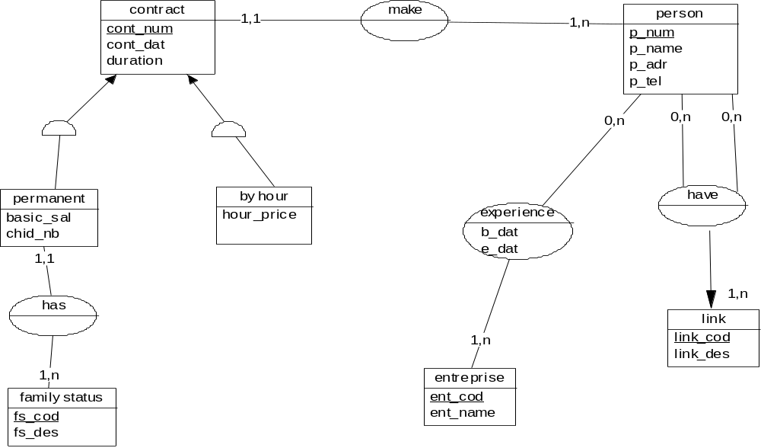

Question 2: Management of horse racing
We wish to manage the participation of the various horses and jockeys in horse racing: know the participants of a race and their rankings. A race takes place always on the same race field (area) and always belongs to the same category (example of category: trotting race, trotting, obstacle...).
We wish to know the race categories that a race field can accommodate.
In addition, We wish to manage the following information:

- the designation of the race (ex: American prize)
- the name of the field of race
- the surface of the field
- the number of spectators seats in the field
- the date of the event
- the endowment of the race (this endowment is variable for each event of a race)
- horses names
- the name and the surname of the horse owner (we assume there is only one and we will not handle the history)
- telephone number of the horse owner.
- the sex of the horse
- the name and surname of the jockeys
- jockeys birth date
- the date of birth of each horse.
- the bib number of the jockey and the horse (common number to the horse and the jockey at an event)
- the classification of the horse in the event of a given race.

NB: we wish in addition to manage direct kinship between horses. A same race can take place several times (multiple events) in the same season (year) on the same field of race and endowments are not always the same. Ex: trotting mounted Auteuil takes place on: March 10, 2014 with an endowment of 5 million, on July 5, 2014, with an endowment of 3 million and on 7 December 2014, with an endowment of 4 million.
Establish the conceptual data model (CDM). (9 pts)

Question 3 : watch repair
A client brings a watch to be repaired; the watchmaker evaluates the amount of work. If the reparation amount is too expensive, he calls the client requesting his agreement (if the cost is greater than 50% of the estimated amount of the watch). Any unrepaired Watch (the client's refusal) is delivered to the client.
When the repair is done, the watchmaker establishes the corresponding invoice and places it in an envelope with the repaired watch.
When the client returns to seek his watch, the watchmaker gives him everything and receives a payment or aims the warranty card, if it is still valid.
If the reparation amount is expensive the watchmaker establishes a guarantee of 3 months, if it had not an original warranty.
Establish the flow chart and the conceptual treatment model (CTM). (6 pts)

